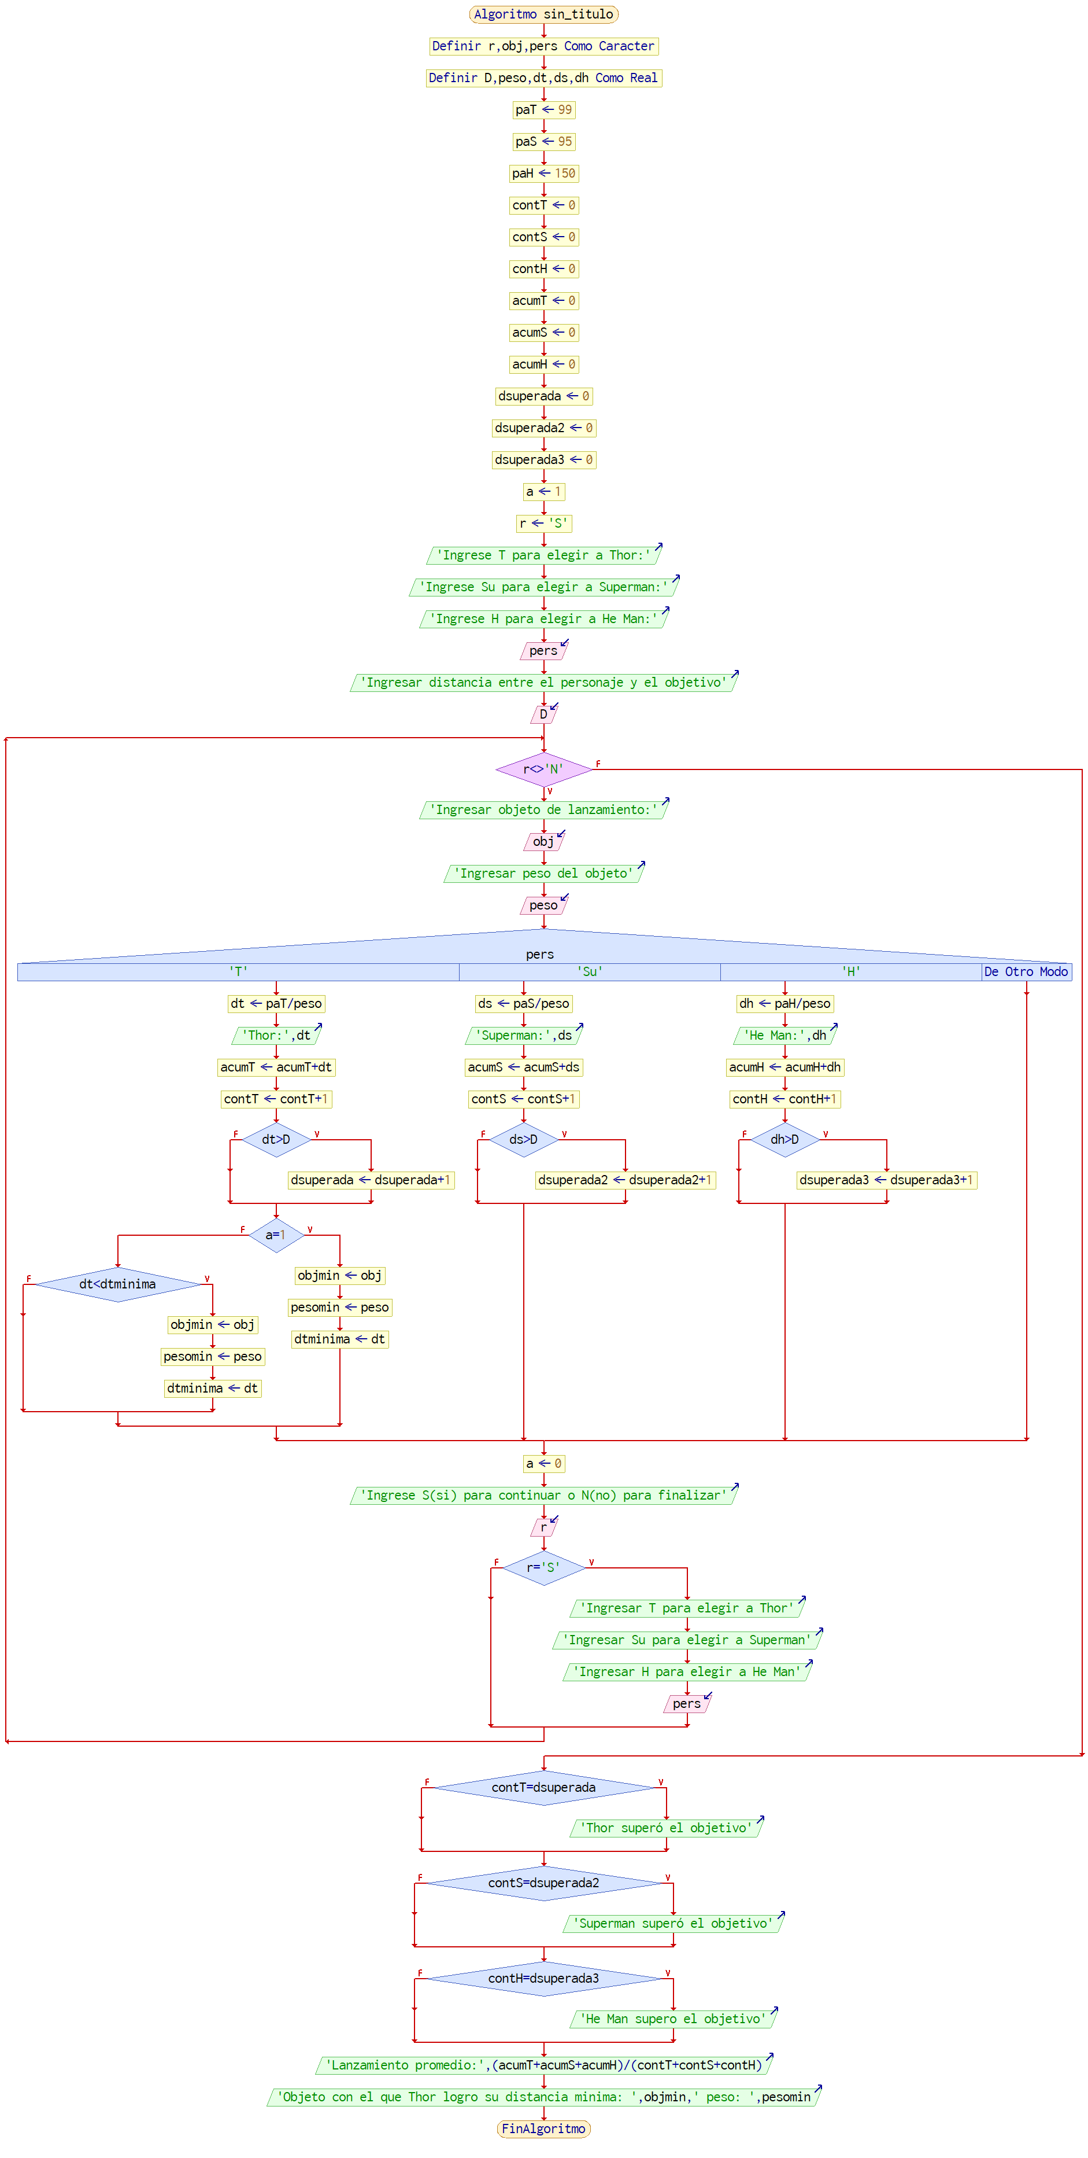Trabajo practico obligatorio

Prueba de escritorio:

|  |  |  |  |  |  |  |  |  |  |  |  |  |  |  |  |  |  |  |  |  |  |  |  |
| --- | --- | --- | --- | --- | --- | --- | --- | --- | --- | --- | --- | --- | --- | --- | --- | --- | --- | --- | --- | --- | --- | --- | --- |
| r | pers | paT | paS | paH | D | obj | peso | dt | ds | dh | contT | contS | contH | acumT | acumS | acumH | dsuperada | dsuperada2 | dsuperada3 | a | objmin | pesomin | dtminima |
| ‘’ | [] | 99 | 95 | 150 |  | [] |  |  |  |  | 0 | 0 | 0 | 0 | 0 | 0 | 0 | 0 | 0 | 1 |  |  |  |
| S | T |  |  |  | 500 | piedra | 50 | 1.98 |  |  | 1 |  |  | 1.98 |  |  | 0 |  |  | 0 | piedra | 50 | 1.98 |
| S | Su |  |  |  |  | cajón | 19 |  | 5 |  |  | 1 |  |  | 5 |  |  | 0 |  |  |  |  |  |
| S | T |  |  |  |  | tren | 155 | 0.64 |  |  | 2 |  |  | 2.62 |  |  | 0 |  |  | 0 | tren | 155 | 0.64 |
| S | H |  |  |  |  | auto | 4.3 |  |  | 24.4 |  |  | 1 |  |  | 24.4 |  |  | 0 |  |  |  |  |
| N |  |  |  |  |  |  |  |  |  |  |  |  |  |  |  |  |  |  |  |  |  |  |  |

Lanzamientos promedio: 6.404

“El objeto con el que Thor logró su distancia mínima: tren, peso: 155”